Creating Five SQL Queries and Data Quality Management Plan
Name
Institution
Date

Creating Five SQL Queries and Data Quality Management Plan
Recently, the Structured Query Language (SQL) has gained traction among the database designers because it provides robust standard language in relational Database Management Systems (DBMS). Continued revisions of the SQL endeavor to accord the standard an international recognition because of better reliability and matching the level conformance requirements (Hoffer, Venkataraman, & Topi, 2016). The protracted fixes and enhancements focus on the in-built functions as well as for analytic query capabilities, which make the SQL a de facto standard language (ibid). The changes in the SQL standard further necessitate the database designers to revisit and address changes in the existing Online Analytic Processing architecture (OLAP) to improve the available data models.
Further, a review on the existing physical design aspects is a core aspect of SQL fixes and improvement that influence the decision-making capabilities of a relational DBMS. A physical database design determines the storage format because it instructs the DBMS about the groups' attributes and improves the querying performance (Hoffer, Venkataraman, & Topi, 2016). The modern fixes and improvements of the SQL standard enhance the processing efficiency using the caliber of physical designs to lower cost-per-unit of measure and users’ interaction time with the system (Ladley, 2012). Therefore, adequate SQL querying hinges on the efficiency in processing the physical files and database to influence the overall suitability of a relational DBMS. The inherent report focuses on achieving completeness in the cadres of SQL queries in Amazon’s relational database management system using five profound statements. The five SQL queries can be clustered into two construct categories that include the Inner-join Operational Construct and Where-conditional construct models.
Modified OLTP Data Models
The share-nothing version additionally introduces an unavoidable downside of sharing: The records spreading out on one of a kind database shards is separated. The question to read or be a part of facts from a couple of database shards must be mainly engineered. It normally incurs a better latency than its peer that runs on most effective one shard. The incapability to offer a consistent, global photograph of all records limits the shared database architecture in playing a lively function inside the online analytic processing (OLAP) surroundings, where facts analytic capabilities are typically completed on the entire dataset. In an internet transaction processing (OLTP) environment, wherein the great extent of writes or transactions can pass past the capability of a single database, and scalability is of problem, sharing is continually really worth pursuing. With the advent of Amazon RDS, database setup and operations were automatic to a large extent. This makes running with a shared database structure a far easier venture. Amazon RDS offers a fixed of database engines, such as Amazon RDS for MySQL, PostgreSQL, SQL Server, Oracle, MariaDB, and Amazon Aurora. You can use any of these as the constructing block for a database shard inside the shared database structure. Figure 1 below depicts the level of horizontal partitioning for Amazon’s RDS.
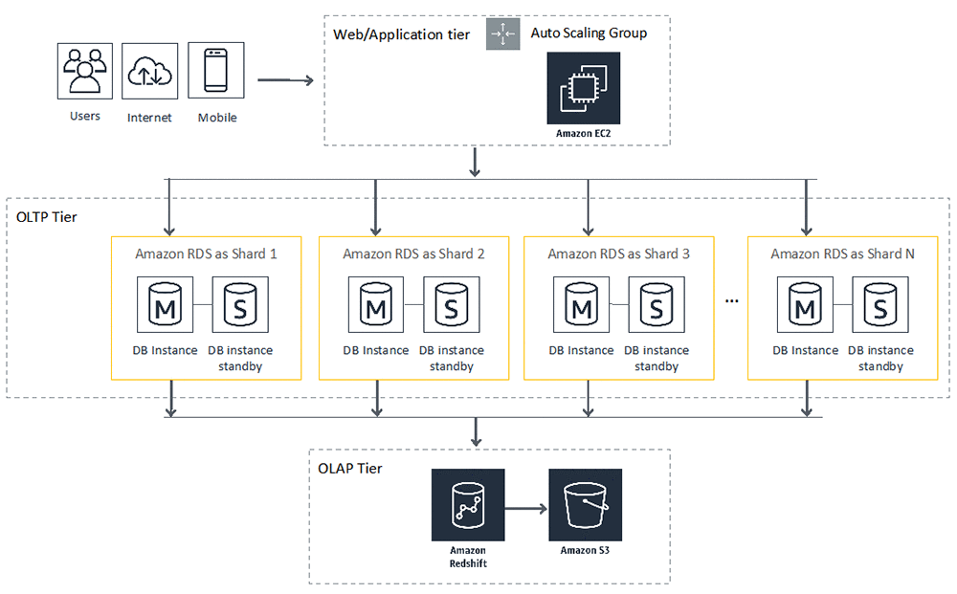
Figure 1: Model of Amazon's RDS and Partitioning
Data Partitioning and Schema Design
The major requirement in implementing shard database architecture is to partition statistics horizontally and distributes data walls throughout database shards. You can use various techniques to partition a table, including list partitioning, variety partitioning, or hash partitioning. You can permit each database shard to accommodate one or more table partitions inside the format of separate tables. The following diagram is an instance of horizontal partitioning within the Invoice desk with customer_id as the partition key.

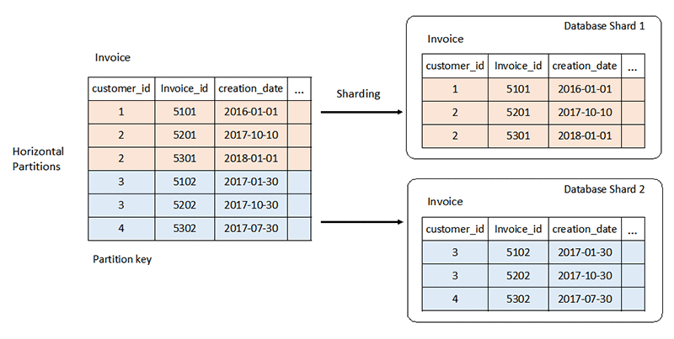
Figure 2 : Horizontal partitioning within the Invoice desk

When a couple of tables are concerned and certain via foreign key relationships, you could achieve horizontal partitioning using the equal Partition key on all of the tables concerned. The information that spans throughout tables; however, belongs to 1 partition key is sent to at least one database shard. The following diagram suggests an example of horizontal partitioning in a set of tables.
Figure 3: Model of Horizontal Partitioning in a Set of Tables
Additional Physical Design Aspect
Besides analyses to determine the conceptual requirements and logical design, another element that necessitates decision-making is a physical design model. A physical design influences the arrangement of the database on the storage devices, which are accessible to the users (Loudon & Loudon, 2014). The core aspects of decision-making include designing fields, de-normalization aspects, partitioning, and file organization (Hoffer, Venkataraman, & Topi, 2016). The four aspects of decision-making that relates to physical database design influence the storage format, instruct the DBMS about the group attributes and enhances the querying performance.
First, a physical database design focuses on the designing field as a key element that influences the mapping capabilities. The designing field aspect entails decisions that concern with the mapping of the attributes of the data in a logical database model using a coding schema (Hoffer, Venkataraman, & Topi, 2016). The type of coding schema that a designer integrates hinges on the DBMS to harness the compatibility of the designing fields. A notable designing field evident in an MS Access caliber of DBMS is the use of NUMBER FIELDs to represent the use of single field-size, double field-size, or text (ibid).
Secondly, the de-normalization aspect of physical database design has a goal to improve the processing performance of Amazon RDS. Hoffer, Venkataraman, & Topi, define de-normalization as a process of undoing the normalized relation to form a non-normalized physical record (2016). De-normalization is applicable when the entities have a one-to-one of many-to-many types of relationship. Thirdly, partitioning is another aspect of physical database design that facilitates a designer to integrate a horizontal-based or vertical-oriented mapping of the rows and columns respectively in relational logical modeling (ibid). Partitioning aims to redistribute the rows or columns into distinctive physical records.
Lastly, a decision to enhance the physical database design relates to file organization to arrange the partitioned records in a physical storage module. The file organization aims to bolster the speed of retrieving files, processing, and maximize the storage spaces (Hoffer, Venkataraman, & Topi, 2016). Multiple approaches used to enhance file organization include sequential file access, indexing, and hashed filing (ibid). Specification on the positioning of a file is a strategic decision that improves the use of storage space in a DBMS.
Five Structured Query Language (SQL) Queries
E.F. Codd articulated the concept of relational database technologies in 1970 using the Sequel language in the project. The success of the relational DBMS in a Sequel standard led to the renaming of the language to the SQL in 1974 and launch of the first IBM’s commercial database management system (Loudon & Loudon, 2014). Thereafter, substantial investments and research projects have been taken to bolster the efficacies of the SQL standard as the de facto language of a relational DBMS.
Importantly, the use of the SQL standard provides multiple advantages to the database designer because it incorporates five distinctive objectives. The primary goals of the SQL standard include specifying the calibers of syntax and semantics available to achieve the universal definition of the data as well as provide unique manipulation languages (Hoffer, Venkataraman, & Topi, 2016). Secondly, the SQL standard defines the data structures that influence the basic operations for designing, accessing, controlling, protecting, and maintaining a relational database (ibid). Further, the SQL standard has been termed as a computing tool that enhances the portability of the database definition between conforming DBMS (ibid). The fourth objective of the SQL standard is to specify the minimum (Level 1) and complete (Level 2) standards that determine the various degree of adoption in the product (Viescas & Hernandez, 2014). Lastly, the SQL language provides an initial standard necessary to facilitate future fixes and improvements (ibid). The notable fixes and improvements include specifications to handles topics that include referential integrity, join operators, trans-action management, and host of emerging capabilities (Hoffer, Venkataraman, & Topi, 2016). Therefore, a decision to formulate ‘inner-join’ operation or ‘where’ conditional construct as the form of pertinent SQL queries aims to maximize the five generic objectives of the SQL standard.
Moreover, the use of relational database model facilitates a data administrator to maximize the power of such database technologies using relationship and construct multiple queries. The SQL standard is particularly appraised because of the ability to get results from multiple tables using the basic syntax of an SQL standard language (DAMA International, 2010). Creating a query, which is an approach used to achieve a database search is the foundation of maximizing the relational database technologies (ibid). However, the available SQL standards that are available from vendors require a system administrator to establish a temporal property in the relational database. A temporary property occurs when a system administrator identifies and maintains the relationship between a primary key and foreign key for the existing relational tables (Hoffer, Venkataraman, & Topi, 2016). Lack of relationship among the existing data tables renders the use of an SQL standard cumbersome or impossible.
Therefore, a practical approach of maximizing the established temporal property and relationships among the multiple data tables is found using the join operation construct or the WHERE clause of the SELECT command. A join operation querying is the most common forms of relational construct because it entails the ability to link together multiple and related tables into a resultant table (Hoffer, Venkataraman, & Topi, 2016). The recent fixes and improvements on the SQL standards have sought to recognize the WHERE clause of SELECT command to be an independent construct (ibid). The pioneer SQL standard tended to imply a join clause to be part of the WHERE clause when used to match common columns of the relational tables (Viescas & Hernandez, 2014). Subsequently, the need for distinction between a join relational construct from an implicit WHERE clause of the SELECT command has yielded several subsets of JOIN…ON commands.
Specifically, the now explicit JOIN…ON relational operation command has seven new subsets of querying constructs. The core modules querying available on the JOIN…ON commands include the INNER, OUTER, FULL, LEFT, RIGHT, CROSS, and UNION (Hoffer, Venkataraman, & Topi, 2016). A database designer must adhere to the principle rule that stipulates the need for a single (one) ON or WHERE construct for each set of tables that are to be joined (Viescas & Hernandez, 2014). The benefits of adhering to the general rule merit because it implies if a database designer wishes to combine two tables, he or she is prompted to use only one ON or WHERE condition is necessary (Ladley, 2012). The use of a single relational operation contrast aims to minimize the cost or storage space in a relational DBMS. Figure 1 below reveals an example of relational data that can be used to demonstrate five queryings using either a JOIN…ON operation or a WHERE condition construct.
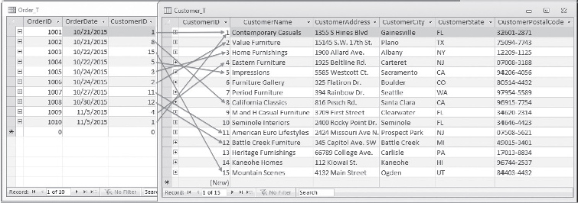
Figure 4: Two Relational Data Tables of Customer_T and Order_T
Examples of JOIN…ON Constructs Using the above relational data tables
(1). Using INNER JOIN…ON Operation
Using a keyword INNER JOIN…ON is a prominent syntax design used in Microsoft Access SQL to achieve a match between tables. Similar to other JOIN…ON model, an INNER JOIN…ON facilitates a database designer to omit the WHERE Condition Clause during a pairing process (Hoffer, Venkataraman, & Topi, 2016). A practical query that suits a querying process is an INNER JOIN…ON construct can relate to a query defined as follows: “what are the customer IDs and name of all customers, along with the order IDs for all the orders placed?” yield the following result.

SELECT Customer_T.CustomerID, Order_T.CustomerID, CustomerName, OrderID
FROM Customer_T INNER JOIN Order_T. ON Customer_T.CustomerID=Order_T.CustomerID
ORDER BY OrderID;
The above querying syntax and design results in 10 rows selected and 3 columns.
Table 1: Answer Table Outcome for an INNER JOIN...ON Operation
CUSTOMER_ID | CUSTOMER1D | CUSTOMERNAME | ORDER_ID
1 | 1 | Contemporary casuals | 1001
8 | 8 | California classics | 1002
15 | 15 | Mountains Scenes | 1003
5 | 5 | Impressions | 1004
3 | 3 | Home Furnishings | 1005
2 | 2 | Value Furniture | 1006
11 | 11 | American Euro Lifestyles | 1007
12 | 12 | Battle Creek Furnitures | 1008
4 | 4 | Eastern furniture | 1009
1 | 1 | contemporary casuals | 1010

Important to note, the use of an INNER JOIN…ON syntax has a redundant column Customer _Id from the table Customer_T and Order_T. The redundant column indicates that our querying process has matched the CustomerID column with the respective name of the tables using the elements of the SELECT list.
(2). Using EQUI- JOIN…ON Operation
Another module of JOIN…ON relational operation is an equi-join construct that focuses on achieving equality between all the values in a common column (Hoffer, Venkataraman, & Topi, 2016). A notable query process that uses an equality-join approach is a statement that stipulates; “what are the Customer IDs and names of all customers, along with the order IDs for all the orders they have placed?” The above query statement can be represented using a WHERE Condition to achieve a comprehensive result.
SELECT Customer_T.ustomerID, Order_T.CustomerID, CustomerName, OrderID
FROM Customer_T, Order_T
WHERE Customer_T.CustomerID= Order_T.CustomerID
ORDER BY OrderID

Similarly, the answer table for an EQUI-JOIN construct querying will also entail 10 rows and 4 columns. The outcomes of an EQUI-JOIN construct that incorporates a WHERE Condition is the same as the one obtains in an INNER JOIN…ON operation. Therefore, the first querying process that omits a WHERE Condition is an effective approach compared to an EQUI-JOIN syntax because the latter consumes more space and yield similar results.
Table 2: Answer Table Outcome for an EQUI-JOIN Operation with a WHERE Condition
CUSTOMER_ID | CUSTOMER1D | CUSTOMERNAME | ORDER_ID
1 | 1 | Contemporary casuals | 1001
8 | 8 | California classics | 1002
15 | 15 | Mountains Scenes | 1003
5 | 5 | Impressions | 1004
3 | 3 | Home Furnishings | 1005
2 | 2 | Value Furniture | 1006
11 | 11 | American Euro Lifestyles | 1007
12 | 12 | Battle Creek Furnitures | 1008
4 | 4 | Eastern furniture | 1009
1 | 1 | contemporary casuals | 1010

(3). Using INNER JOIN…USING Operation Keyword
The use of an INNER JOIN…USING syntax is merits because it allows database designers enhanced flexibility than the INNER JOIN…ON and an EQUALITY JOIN operation. The INNER JOIN…USING represents the recent fixes and improvements of the SQL standards and relational database technologies because it facilitates the designer to plan and eliminate the redundant columns. A notable strategy is to use identical titles for the columns that involve the primary and foreign keys. Therefore, the querying statement, “what are the Customer IDs and names of all customers, along with the order IDs for all the orders they have placed?” yields the following constructs.
SELECT Customer_T.ustomerID, Order_T.CustomerID, CustomerName, OrderID
FROM Customer_T, INNER JOIN Order_T USING CustomerID
WHERE Customer_T.CustomerID = Order_T.CustomerID
ORDER BY OrderID

An important observation that relates to an INNER JOIN…USING construct relates to the flexibility in using the WHERE CONDITIONAL clause. The INNER JOIN…USING syntax process relegate the use of conditional constructs to serve the role of a traditional filter when needed (Hoffer, Venkataraman, & Topi, 2016). The contemporary database designers prefer to use the syntax ON or USING in the FROM Clause to replace the unnecessary and save on space for the relational database system (Ladley, 2012). Therefore, the use of INNER JOIN…USING is advantageous than the other querying structures of an INNER JOIN…ON and EQUI-JOIN syntax in a relational database management system because of the highest level of flexibility as well as efficiency.
(4). Using NATURAL JOIN Operation Construct
The fourth model of querying available for a relational-base database system is a NATURAL JOIN construct. NATURAL JOIN syntax is a modification of an EQUALITY JOIN used to over-match the related columns and eliminates redundancy in the result table (Hoffer, Venkataraman, & Topi, 2016). A NATURAL JOIN is useful to eradicate the use of a WHERE Conditional Clause is relational database management. On the other hand, a NATURAL JOIN can be used as an alternative keyword when the querying process defines a joins in the FROM Clause. A practical construct statement that incorporates a NATURAL JOIN is useful in a scenario that necessitates the designer to determine the customer’s ID, name, and order number for each consumer in a relational database.
SELECT Customer_T.CustomerID, CustomerName, OrderID
FROM Customer_T, NATURAL JOIN Order_T ON Customer_T.CustomerID = Order_T.CustomerID

(5). Using OUTER JOIN Querying Structure
Lastly, an OUTER JOIN is an effective conditional construct when used to link two tables. Usually, an OUTER JOIN structure is applicable in a scenario where a row in one of the relational table fails to match with another row (Hoffer, Venkataraman, & Topi, 2016). Figure 1 above reveals several CustomerIDs fails to match with any of the row in the ORDER_T table. Therefore, it is assumed the customers whose IDs fail to link with the ORDER_T are yet to make payment for their goods. An effective querying process has a duty to facilitate an organization to identify such consumers and make follow up. An OUTER JOIN is applicable in a query that requires database designer to list the name of customers, identification number, and order number for all the buyers listed in the Customer table.

SELECT Customer_T.CustomerID, CustomerName, OrderID
FROM Customer_T, LEFT OUTER JOIN Order_T
WHERE Customer_T.CustomerID = Order_T.CustomerID

Amazon’s Data Quality Management Plan
System administrators acknowledge having SQL standard is not a panacea to multifaceted challenges of quality data management. Achieving quality data and safeguarding against infringement serves an integral part of information processing and seamless management of an organization (Loudon & Loudon, 2014). Amazon has a fiduciary to institute data governance structures to hedge against exposure to myriad risks (Hoffer, Venkataraman, & Topi, 2016). Data governance refers to the procedures that an organization institutes to influence the management of the data. Therefore, an effective technical plan adheres to the stipulated set of processes and procedures to enhance availability, integrity, and compliance (Hoffer, Venkataraman, & Topi, 2016). Amazon.com has an elaborate technical plan that addresses the architecture management function within the organization. The Amazon Relational Database Service (Amazon RDS) is a profound technical plan that influences the ability to achieve proactive management capabilities and guarantees service continuity (Loudon & Loudon, 2014). Further, the Amazon RDS technical plan also entails reactive structures that facilitate the management to resolve issues that emanate from non-compliance.

References
Cook B. (2018). “Formal reasoning about the security of Amazon Web Services,” Chockler H., Weissenbacher G. (eds) Computer Aided Verification. CAV 2018. Lecture Notes in Computer Science, vol 10981. Springer, Cham
DAMA International. (2010). The DAMA Guide to the data management body of knowledge (DAMA-DMBOK), First Edition. New Jersey: Technics Publication
Hoffer, J., Venkataraman, R. & Topi, H. (2016).Modern database management, (12th Edition), Pearson
Ladley, J. (2012). Data governance: How to design, deploy and sustain an effective data governance program, Morgan Kaufmann
Loudon, J. & Loudon, K. (2014). Management Information System: Managing Digital Firm, (13th Ed.), Boston; MA, Pearson
Viescas, J. & Hernandez, J. (2014). SQL queries for mere mortals: A hands-on guide to data manipulation in SQL. Upper Saddle River, NJ: Addison-Wesley.

